**Title Page:**

Game Name: Project Intern

Game Logo: N / A

Game Catch Phrase: N / A

Document Type: Word Document

Document Version: V1.0

**Credit Page:**

Document Purpose: A general overview of the game.

Document Version: V1.0

Working Title: Project Intern

Game Concept: Top down, 2D, arcade game

Game Document Author: Spencer Hendon

**Sign Off:**

Lead Artist: Spencer Hendon

Lead Designer: Spencer Hendon

Lead Programmer: Spencer Hendon

Lead Producer: Spencer Hendon

**Introduction:**

This game is a top down, 2D, adventure game. The player is a new intern in an office. He must fight the other interns to get the job.

**Game Analysis:**

**Game Description:**

Genre: Adventure

Game Elements: Collecting, Chase, Combat

Game Content: Normal

Theme: Normal

Style: Real

Player: One

**Game Reference:**

Game Taxonomy: Project Intern is a fictional game

Player Immersion: Tactial

Reference: N/A

**Game Technical:**

Technical Form: 2D graphics

View: Platformer/action

Platform: PC

Language: Java

Device: PC

**Game Sales:**

Consumer Group: Everyone

Payment: The game is free

Estimated Price: Free

**Game Atmosphere:**

The game starts with a happy mood, but as the game progresses, it becomes scarier.

**Game Play:**

The game will open to the title screen. You can play as an already created player, or you can create a new player. There is only one mode called survival. You must compete against other interns (AI) who are competing for an official job at the office. You lose the game by dying to the other interns. You win by killing the other interns. You have to commit yourself and focus on the game.

**Key Features:**

There is currently one level but possibly more. There is a randomly generated number of interns (enemies). The game playtime is determined by how quickly you kill the other interns. You have an ability to replay the game since the interns are generated randomly. The game is single player only.

**Selling Features:**

Original idea.

**Design Document:**

**Design Version:**

J1.0

**Design Guidelines:**

2D Pixel Art

**Game Design Definitions:**

* Player wins by killing other interns. Player loses by dying to the other interns.
* Player can control the player with the arrow keys or “WASD” keys.
* The game is going to be medium paced.

**Game Matrix:**

|  |  |  |  |  |
| --- | --- | --- | --- | --- |
| Player | Jaycob | Zane | Spencer | Nate |
| Enemies | Interns |  |  |  |
| Objects | Office | Home | Car |  |
|  |  |  |  |  |
|  |  |  |  |  |

**Game Storyboard:**

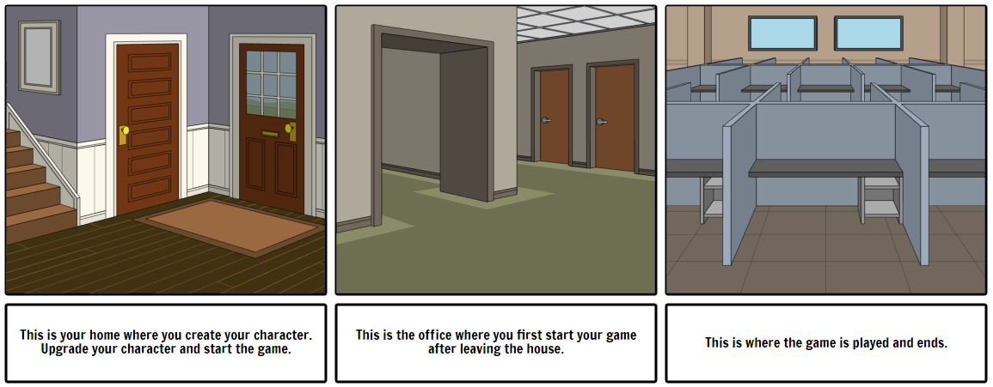

**Flow Chart:**

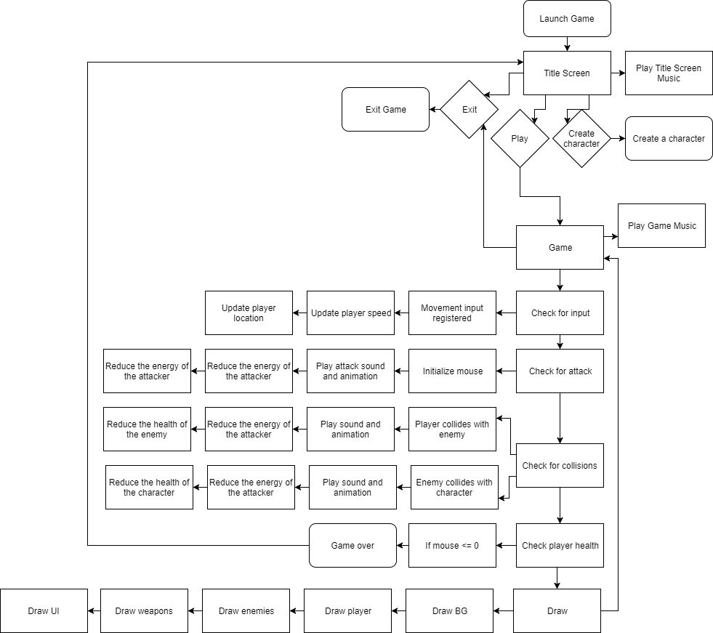

**Player Elements:**

Player:player

The player is an intern. He is 2D.

**Player Traits:**

Smart – You must quick and wise decisions otherwise, you might die.

Fearless – You must be willing to go out of your comfort zone and complete the task. If you are not willing to do that, then you will not get very far.

**Player Definition:**

Default status: not moving

Actions: jump, attack

Information: Number of lives, DP

Default Properties: Begins game at the first floor in the office

Winning: Destroy server

Losing: You die

**Player Properties:**

Health: 100/100

Weapons: Mouse, keyboard, USB stick, and hornets.

Actions: Jump, crouch, move, and attack.

**Player View:**

2D platform

**Player Backstory:**

You were an intern at a major corporation named “Clandestine Corp.” The intern process was a very intense competition to become a full time member. The other interns sabotaged you. You are now on a mission to destroy the other interns. You must infiltrate the corporation, find the applications for the other interns, and then destroy those applications. You destroy the applications by wiping the server.

**Player Rewards:**

Skill tree

**Player View:**

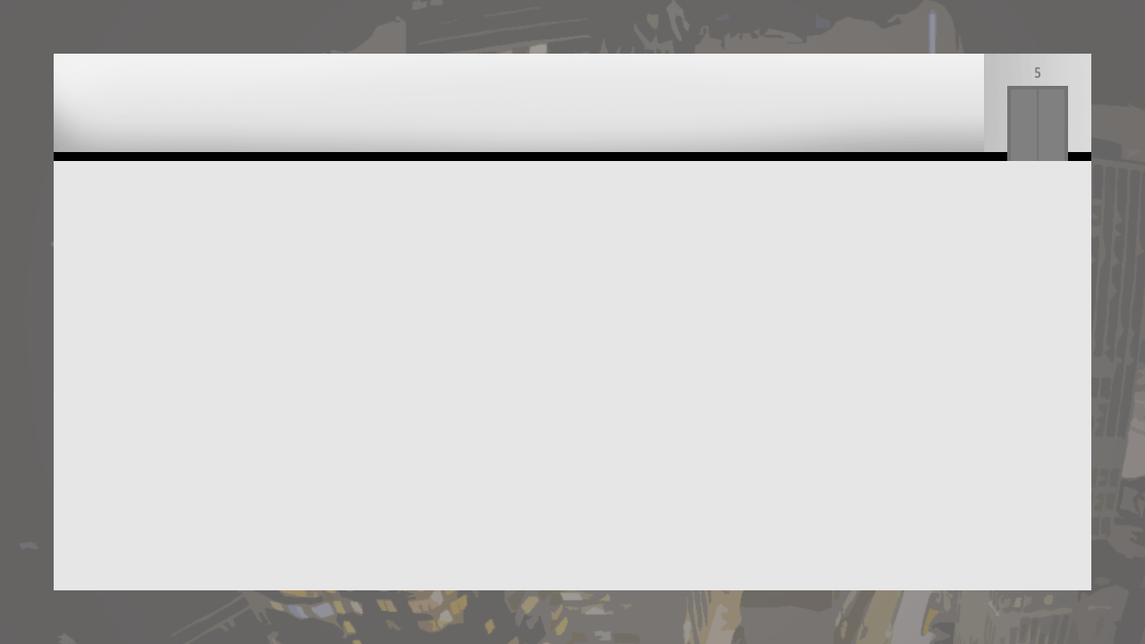

Work in progress

**User Interface:**

XP, level, and energy

**Antagonistic Elements:**

Enemies: enemies

**Antagonistic Definitions:**

Enemies: Opponents

**Antagonistic Properties:**

Enemies: They are other interns so they can perform similarly to the player.

**Antagonistic List:**

Enemies

**Artificial Intelligence:**

Normal state: Minding his or her own business and doing normal intern work.

Detection state: Player must enter within a certain range of the player.

Reaction state: Attack the player.

End state: Either die or the player dies.

**Global Game Elements:**

Office walls, desks, weapons, enemies

**The Story:**

You were an intern at a major corporation named “Clandestine Corp.” The intern process was a very intense competition to become a full time member. The other interns sabotaged you. You are now on a mission to destroy the other interns. You must infiltrate the corporation, find the applications for the other interns, and then destroy those applications. You destroy the applications by wiping the server.

**The Story Copy:**

You must take down a major corporation name “Clandestine Corp.” To do this, you must infiltrate to office and destroy the applications of the new interns and ultimately destroy the corporations server.

**Concept Art:**

None atm.

**Level Design:**

Seven floors in an office. Five floors above ground. Two floors below ground.

**Level Copy:**

None atm.

**Audio and Sound FX:**

Jump sounds, attacking sound, losing sound, winning sound, background music

**Game Architecture:**

Title Screen, Game Screen, Character Creation Screen.

**Game Architecture Overview:**

A very simple high score.

**Architecture Copy:**

None atm.

**How to play copy:**

Use arrow keys or “WASD” keys to move. Use space to jump. You can use the elevator to traverse floors in the office. You must eliminate the interns in the office.

**Libraries that are used:**

Unknown

**External File Formats:**

* PNG – Pictures
* JPG – Pictures
* MP3 – Music

**Types of physics:**

No physics.

**Language used:**

C#

**Technical Document:**

**System Requirements:**

Computer with Java.

**Visual Content:**

**General:**

- File size restrictions: none

- File format type: .jar

- File quality type: to be determined

- Visual scale: 720p

**Player Elements:**

- Type of states: Default, Moving, still, Dead

- Amount of Animation Frames: to be determined

**Heads Up Display (HUD):**

- Type Icons: to be determined

- States: Always on

- Font type: to be determined

**Antagonistic Elements:**

- Type of states: Default, Moving, still, Dead

- Amount of Animation Frames: to be determined

**Global Elements:**

- Background/Texture/Tiles

-Font type: to be determined.

**Audio Content:**

**General:**

- File size restrictions: none

- File format type: .jar

- File quality type: to be determined

**Player Elements:**

- Unknown type of sound effects

- No device vibrations

**Antagonistic Elements:**

- Unknown type of sound effects

- No device vibrations

**Global Elements:**

- Ambient music

**Splash Screens:**

- To be determined

**Menus:**

- Title Screen

- Game Screen

**Programming Content:**

**General:**

- Requirements: Java

- File size restrictions: none

- File format type: .jar

- Coding Conventions: Unknown

- Language Restrictions: English only

- Device Restrictions: Java

- Screen type: all

**Player Elements:**

- Character event

**Antagonistic Elements:**

- Enemy event

**Global Elements:**

- Unknown event

**Splash Screens:**

-Loading event

**Menus:**

- Unknown event

**Code Structure:**

Unknown

**Concerns and Alternatives:**

Time management.

**Resources:**

IDE: Netbeans

Language: Java

**Technical Matrix:**

Unknown